1. A screenshot of VS Code showing app.py from the file Module 11 Final Assignment.zip.

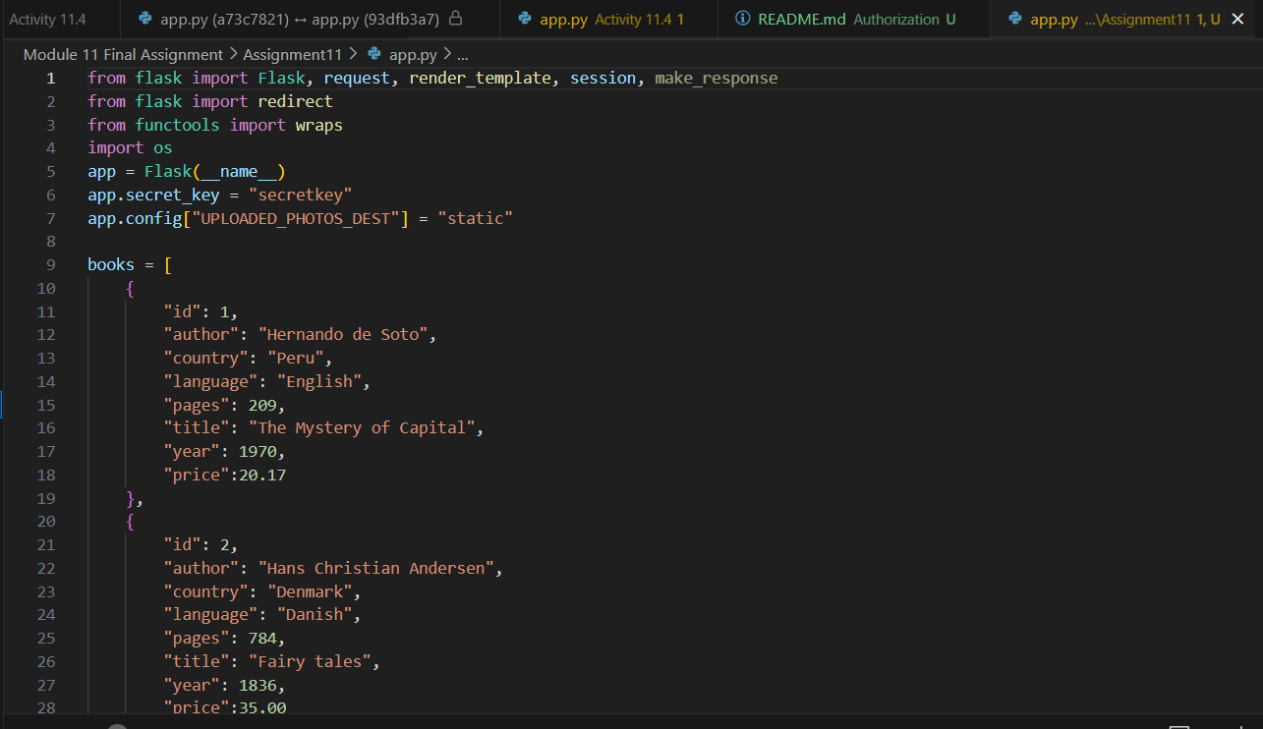

1. A screenshot of the web browser pointing to “http://localhost:5000” and showing the application running.

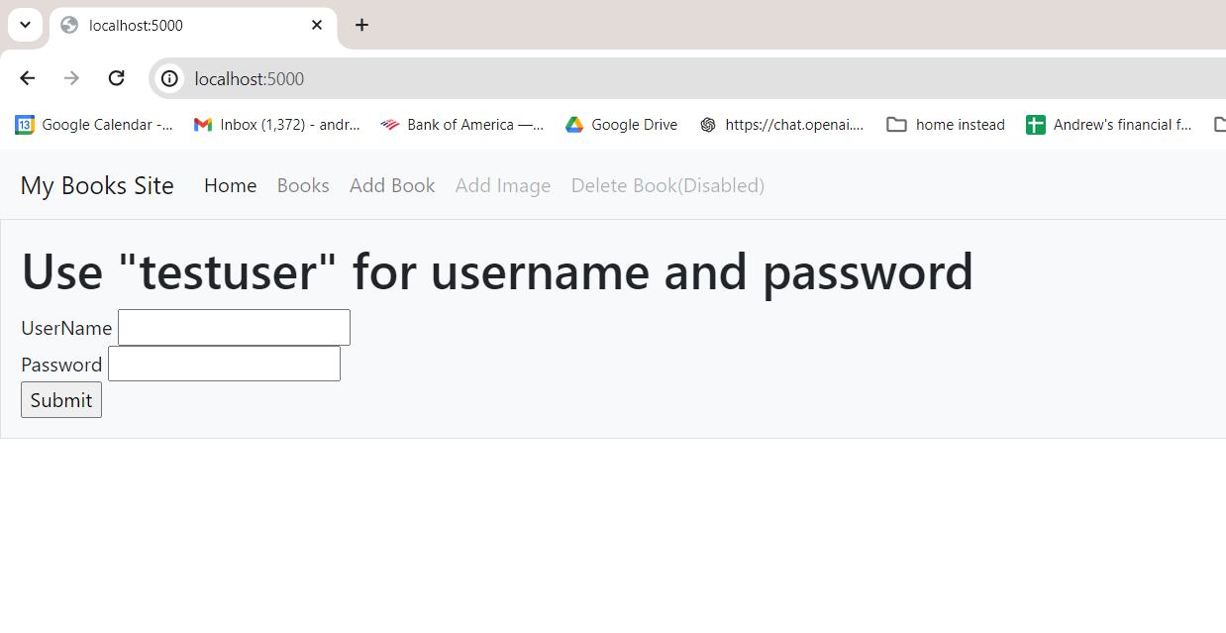

1. A screenshot of the Books table modified using Bootstrap.

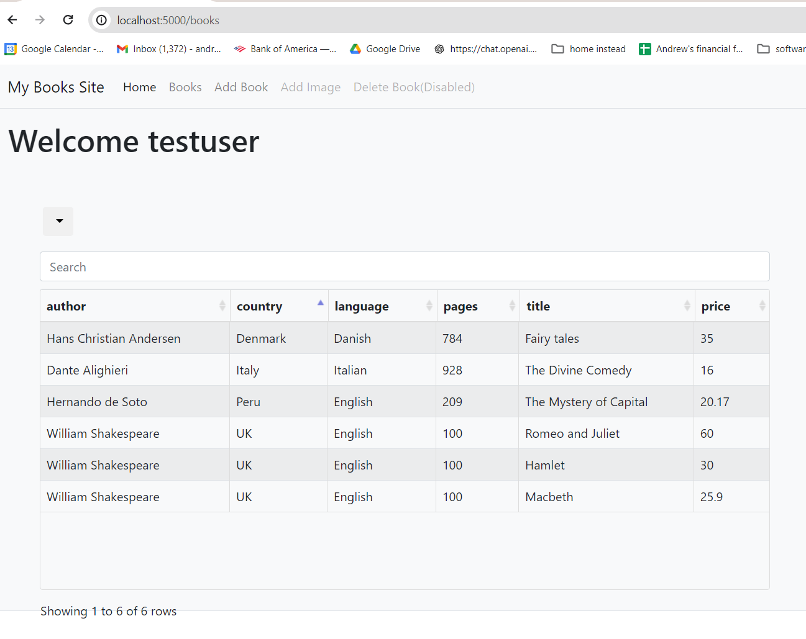

1. Complete the code and provide:
   1. A screenshot showing that the booksToPurchase *cookie* has been added to app.py.

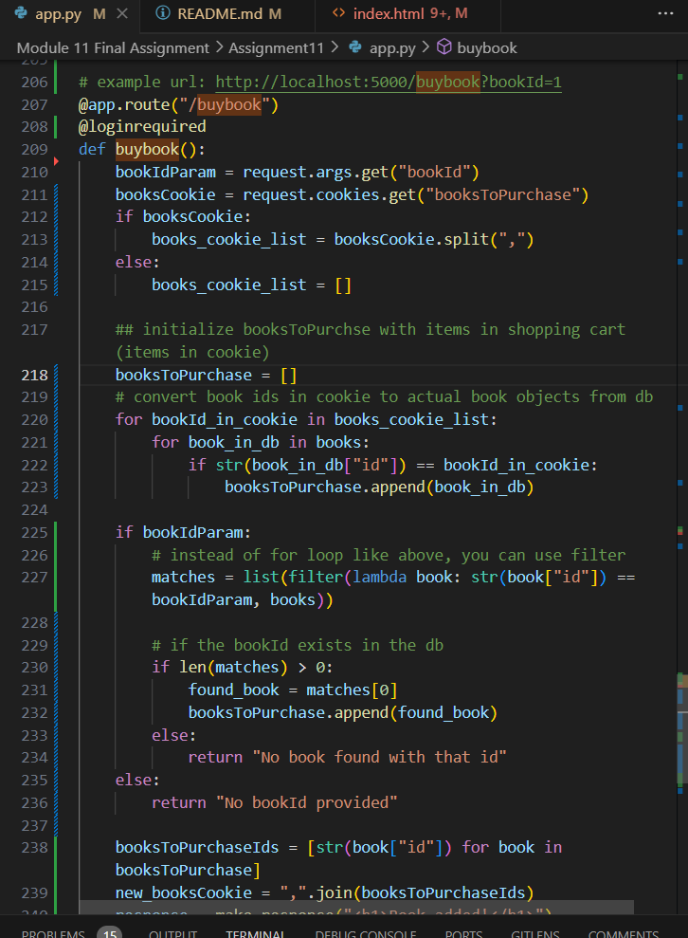

* 1. A screenshot of the *for loop* used to find the book that a user wants to purchase. (Using filter instead of for loop)

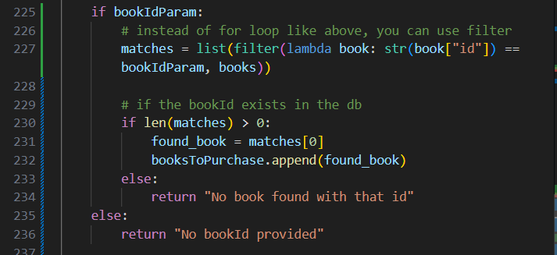

* 1. A screenshot showing that you set the *cookie* booksToPurchase with the updated list of bookId.

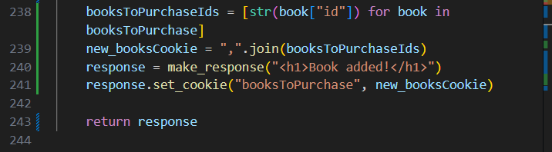

* 1. A screenshot showing that you returned the correct response object.



1. A screenshot showing that you created a striped table of the books you want to purchase.

